Student Name: ______________________ Block A Teacher: _____________________

During your Exit Interview in June, you will be asked to share both a personal and academic achievement from your Grade 9 Year.

- A personal achievement is something you have accomplished OUTSIDE of school THIS YEAR. Example: You learned how to snowboard.

- An academic achievement is something you are proud of achieving THIS SCHOOL YEAR. It does not have to relate to assessment (a grade). Example: You are proud of the dramatic video you created in Video Production class.

Please read the instructions carefully and fill in the applicable information in the boxes provided.
Return to your BLOCK A TEACHER.

DUE: April 3^{rd,} 2023

Big Ideas:
- Achieving our learning goals requires effort and perseverance.
- Our career paths reflect the personal, community, and educational choices we make.

Curricular Competencies:
- Use self-assessment and reflection to develop awareness of their strengths, preferences and skills.
- Set and achieve realistic learning goals with perseverance and resilience.

Proficiency Scale:
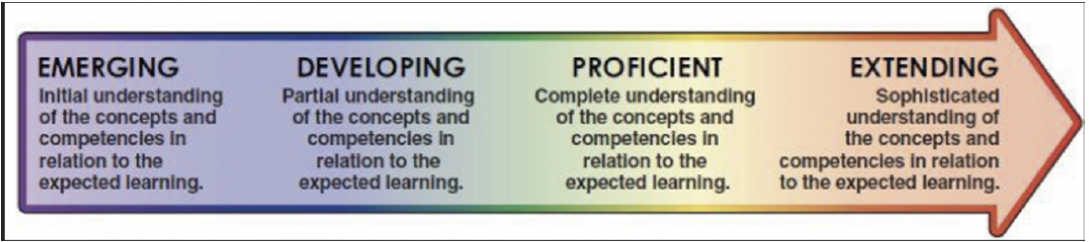

Personal Achievement

What have you accomplished OUTSIDE of school THIS YEAR?

Example: You learned how to snowboard.

Accomplishment:
- Example: Earned my Bronze Cross Medallion in Swimming

Description of Achievement:
- Describe the event, activity, or experience with detail. Include the facts – who, what, when, where, why and how.

Personal Relevancy:
- Reflect on how this was/is important, meaningful, special, and/or worthwhile for you.

Skill Development:
- Describe the skills you learned, improved and practiced. Explain the transferable skills gained and connect those skills to your future aspirations.

Self-Awareness:
- What did you learn about yourself? Reflect upon your strengths, areas for self-improvement, interests, values, motivations, likes/dislikes, barriers, challenges etc.

Future Connections:
- How does this experience connect you to your future plans? How could you apply any lessons learned or insights gained from this experience to other situations?

Academic Achievement

What have you achieved THIS SCHOOL YEAR that you are proud of?
Example: You learned how to do an oil change in Auto Shop.

Accomplishment:
- Example: I was struggling in math with fractions but asked for help and was finally able to understand it.

Description of Achievement:
- Describe the event, activity, or experience with detail. Include the facts – who, what, when, where, why and how.

Personal Relevancy:
- Reflect on how this was/is important, meaningful, special, and/or worthwhile for you.

Skill Development:
- Describe the skills you learned, improved and practiced. Explain the transferable skills gained and connect those skills to your future aspirations.

Self-Awareness:
- What did you learn about yourself? Reflect upon your strengths, areas for self-improvement, interests, values, motivations, likes/dislikes, barriers, challenges etc.

Future Connections:
- How does this experience connect you to your future plans? How could you apply any lessons learned or insights gained from this experience to other situations?

